**25.78 Gbps SFP28 SR Transceiver**

**SOSP-8525G-SR**

(Preliminary)

**Features**

* Up to 25.78Gbps bi-directional data links
* Hot pluggable SFP+ footprint
* Built-in digital diagnostic functions
* 850nm VCSEL and PIN receiver
* Duplex LC connector
* 70m over MMF(50/125µm OM3)
* Single +3.3V power supply
* Low power consumption
* Operating case temperature: 0~+70°C

**Applications**

* 25.78 Gb/s single lane 100GE SR4

**Description**

The SOSP-8525G-SRSFP28 SR Transceivers are designed for use in 25Gbps data rate over multimode fiber. They are compliant to IEEE802.3by, SFF-8472 Rev 12.2 and SFF-8402, and compatible with SFF-8432 and applicable portions of SFF-8431 Rev. 4.1. The optical transceiver is compliant per the RoHS Directive 2011/65/EU.

**Specification**

|  |  |  |  |  |  |  |
| --- | --- | --- | --- | --- | --- | --- |
| **Absolute Maximum Ratings** | | | | | | |
| **Parameter** | **Symbol** | **Min** | **Typical** | **Max** | **Unit** | **Notes** |
| Storage Temperature | TS | -40 | - | 85 | ºC |  |
| Maximum Supply Voltage | VCC | -0.3 | - | 4 | V |  |
| Relative Humidity | RH | 0 | - | 85 | % |  |
| Case Operating Temperature | TC | 0 | - | 70 | ºC |  |

|  |  |  |  |  |  |  |
| --- | --- | --- | --- | --- | --- | --- |
| **General Specifications** | | | | | | |
| **Parameter** | **Symbol** | **Min** | **Typical** | **Max** | **Unit** | **Notes** |
| Data Rate | DR |  | 25.78125 |  | Gbps | +/-100ppm |
| Bit Error Rate | BER |  |  | 5E(-5) |  |  |
| Fiber Length on 50/125μm OM3 MMF | L |  |  | 70 | m | 1 |

Notes:

1. At 25.78Gb/s Ethernet data rate (IEEE 802.3by)

|  |  |  |  |
| --- | --- | --- | --- |
| **Pin Descriptions** | | | |
| **Pin** | **Symbol** | Name/Description | Ref. |
| 1 | VEET | Transmitter Ground (Common with Receiver Ground) | 1 |
| 2 | TXFAULT | Transmitter Fault. | 2 |
| 3 | TXDIS | Transmitter Disable. Laser output disabled on high or open. | 3 |
| 4 | SDA | 2-wire Serial Interface Data Line (MOD-DEF2) | 4 |
| 5 | SCA | 2-wire Serial Interface Clock (MOD-DEF1) | 4 |
| 6 | MOD_ABS | Module Absent, connected to VEET or VEER | 4 |
| 7 | RS0 | NA | 5 |
| 8 | LOS | Loss of Signal indication. Logic 0 indicates normal operation. | 6 |
| 9 | RS1 | NA | 5 |
| 10 | VEER | Receiver Ground (Common with Transmitter Ground) | 1 |
| 11 | VEER | Receiver Ground (Common with Transmitter Ground) | 1 |
| 12 | RD- | Receiver Inverted DATA Out. AC Coupled |  |
| 13 | RD+ | Receiver Non-inverted DATA Out. AC Coupled |  |
| 14 | VEER | Receiver Ground (Common with Transmitter Ground) | 1 |
| 15 | VCCR | Receiver Power Supply |  |
| 16 | VCCT | Transmitter Power Supply |  |
| 17 | VEET | Transmitter Ground (Common with Receiver Ground) | 1 |
| 18 | TD+ | Transmitter Non-Inverted DATA In. AC Coupled. |  |
| 19 | TD- | Transmitter Inverted DATA In. AC Coupled. |  |
| 20 | VEET | Transmitter Ground (Common with Receiver Ground) | 1 |

Notes:

1. Circuit ground is internally isolated from chassis ground.

2. TXFAULT is an open collector/drain output, which should be pulled up with a 4.7k – 10k Ohms resistor on the host board if intended for use. Pull up voltage should be between 2.0V to Vcc + 0.3V. A high output indicates a transmitter fault caused by either the TX bias current or the TX output power exceeding the preset alarm thresholds. A low output indicates normal operation. In the low state, the output is pulled to <0.8V.

3. Laser output disabled on TXDIS >2.0V or open, enabled on TXDIS <0.8V.

4. Should be pulled up with 4.7k – 10kohms on host board to a voltage between 2.0V and 3.6V. MOD_ABS pulls line low to indicate module is plugged in.

5. Rate select is not applicable.

6. LOS is open collector output. Should be pulled up with 4.7k – 10kohms on host board to a voltage between 2.0V and 3.6V. Logic 0 indicates normal operation; logic 1 indicates loss of signal.



|  |  |  |  |  |  |  |
| --- | --- | --- | --- | --- | --- | --- |
| **Electrical Specification** | | | | | | |
| **Parameter** | **Symbol** | **Min** | **Typical** | **Max** | **Units** | **Notes** |
| Supply Voltage | Vcc | 3.15 |  | 3.46 | V |  |
| Supply Current | Icc |  |  | 250 | mA |  |
| **Transmitter** |  |  |  |  |  |  |
| Differential input impedance | Zin |  | 100 |  | Ohm |  |
| Differential input voltage amplitude | Vin | 180 |  | 1600 | mVp-p |  |
| Transmit Disable Voltage | Vd | 2 |  | Vcc | V |  |
| Transmit Enable Voltage | Ven | Vee |  | Vee+0.8 | V |  |
| **Receiver** |  |  |  |  |  |  |
| Differential Output impedance | Zout |  | 100 |  | Ohm |  |
| Differential output voltage amplitude | Vout | 370 |  | 850 | mVp-p |  |
| LOS On | VIH | 2.0 |  | VCChost | V |  |
| LOS Off | VIL | Vee |  | Vee+0.8 | V |  |
| Power Supply Rejection | PSR | TBD |  |  | mVp-p |  |

|  |  |  |  |  |  |  |
| --- | --- | --- | --- | --- | --- | --- |
| **Optical Specification** | | | | | | |
| **Parameter** | **Symbol** | **Min** | **Typical** | **Max** | **Units** | **Notes** |
| Supply Voltage | Vcc | 3.15 |  | 3.46 | V |  |
| **Transmitter** |  |  |  |  |  |  |
| Average Output Power | Pout | -8.4 |  | 2.4 | dBm | 1 |
| Optical Wavelength | λ | 840 |  | 860 | nm | 1 |
| Spectral Width(RMS) | σ |  |  | 0.6 | nm | 1 |
| Optical Modulation Amplitude | OMA | -6.4 |  | 3 | dBm | 1 |
| Transmitter Dispersion Penalty | TDP |  |  | 5 | dB | 2 |
| Relative Intensity Noise | RIN |  |  | -128 | dB/Hz |  |
| Extinction Ratio | ER | 2 |  |  | dB | 1 |
| Optical Return Loss Tolerance | RL |  |  | 12 | dB | 1 |
| **Receiver** |  |  |  |  |  |  |
| Stressed Receiver OMA Sensitivity | SENS |  |  | -5.2 | dBm | 1 |
| Average Receiver Power | Prx | -10.3 |  | 2.4 | dBm | 1 |
| Optical Center Wavelength | λc | 840 |  | 860 | nm | 1 |
| LOS De-Assert | LOSd |  |  | -13 | dBm |  |
| LOS Assert | LOSa | -30 |  |  | dBm |  |
| LOS Hysteresis | LOSh | 0.5 |  |  | dB |  |

Notes:

1. Per IEEE 802.3by
2. Informative only

**Digital Diagnostic Functions**

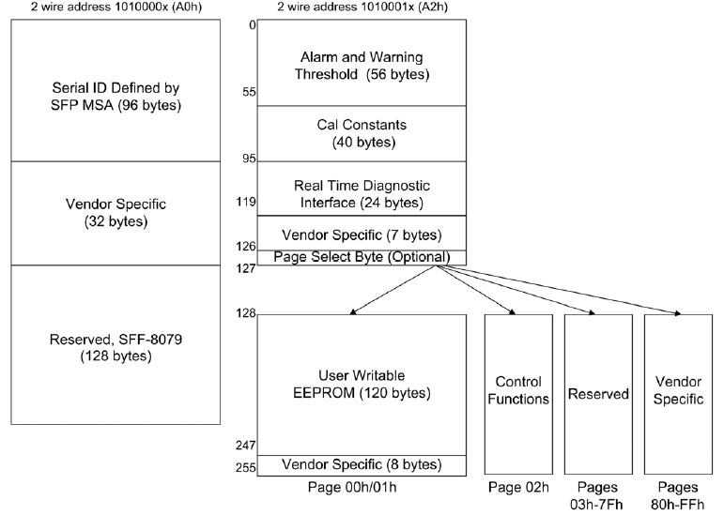

**TWO-WIRE INTERFACE FIELDS**

The operating and diagnostics information is monitored and reported by a Digital Diagnostics Transceiver Controller (DDTC) inside the transceiver, which is accessed through a 2-wire serial interface. When the serial protocol is activated, the serial clock signal (SCL, Mod Def 1) is generated by the host. The positive edge clocks data into the SFP transceiver into those segments of the E2PROM that are not write-protected. The negative edge clocks data from the SFP transceiver. The serial data signal (SDA, Mod Def 2) is bi-directional for serial data transfer. The host uses SDA in conjunction with SCL to mark the start and end of serial protocol activation. The memories are organized as a series of 8-bit data words that can be addressed individually or sequentially.

For more information, please see the SFP MSA documentation.

**Digital Diagnostic Specifications**

|  |  |  |  |  |  |  |
| --- | --- | --- | --- | --- | --- | --- |
| **Parameter** | **Symbol** | **Min** | **Max** | **Unit** | **Accuracy** | **Notes** |
| Transceiver Case Temperature | ºC | 0 | 70 | ºC | ±5℃ |  |
| Transceiver Supply Voltage | V | 3.15 | 3.46 | V | ±0.1V |  |
| Transmitter Bias Current | mA | 0 | 12 | mA | ±10% |  |
| Transmitter Output Optical Power | dBm | -9 | 2.4 | dBm | ±3dB |  |
| Receiver Average Input Optical Power | dBm | -11 | 2.4 | dBm | ±3dB |  |

**Mechanical Specifications**

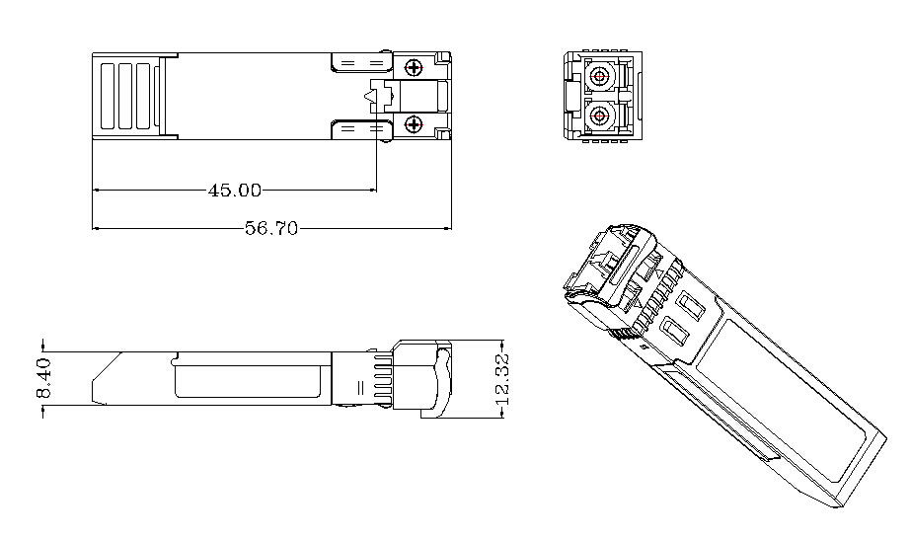

**Contact**

Shenzhen Sinovo Telecom Co. Ltd

[Website:www.sinovocorp.com Email:sales@sinovocorp.com](mailto:sales@sinovocorp.com)

Tel:+86(0)0755-3295 9919 Fax:+86(0)755 3295 9918

FactoryADD: 4~5F,NO.658,Meijing West Rd,Dalang Town, Dongguan City, Guangdong,China

Head Quarter:11/F,Taibang Technology Building,Gaoxin South 4th,Science and

Technology Park South,Nanshan,Shenzhen,China 518040